
Australian Academy of Science

Summer Program in Australia – 2007.

30 DAY - RESEARCH REPORT

PART A

Your report will assist the Australian Academy of Science to meet its reporting requirements
to the Commonwealth of Australia. It will also help the Academy in the organisation of future Summer Programs for US graduate students. You are not limited by the space provided below and you can expand any of the items below as you see fit. If you wish to include attachments and/or photos, you are welcome to do so.

- Name, business address and email address:
Gregory Crosswhite
University of Washington
Department of Physics
Box 351560
Seattle WA 98195-1560

gcross@u.washington.edu

- Current status

Master course  Doctor course Postdoctoral researcher
- The title of your research project.

- The name and address of your host(s).

- What is the primary motive for your participation in the program? (Chose one answer only)

To gain specific knowledge related research to your current research
To work with a particular researcher at a particular lab

To work on a particular research project

To acquire international research experience

To experience life in Australia

- It is expected that your participation in the Summer Program with Australia would enhance your research experience and promote collaborative opportunities.

Please indicate if and how your visit to Australia achieved these outcomes and if there were other immediate benefits of the visit to your personal research work such as papers expected to be published, presentations, etc

- Were the pre-departure communications useful to you in preparing to participate in the program?

useful not useful
If you chose 'not useful' please explain.

- Was the information provided at the orientation sufficient?

 sufficient not sufficient
If you chose 'not sufficient' please explain.

- How often did you exchange research options or ideas with Australian researchers other than your host?

daily often occasionally seldom

- How do you evaluate the degree to which you achieved your research objective?

 beyond expectation fully accomplished satisfactory unsatisfactory
If you chose 'unsatisfactory' please explain.

- What aspects of the program were the most interesting and valuable to you?

- How do you evaluate the overall program?

 excellent good satisfactory unsatisfactory

- Having experienced research and life in Australia, what do you think the possibility is of your conducting future research in Australia?

Would like to create opportunities

If a favourable opportunity arises

Not interested

- Please add your comments (if any):

30 DAY - RESEARCH REPORT

PART B

Participants name: Gregory Crosswhite

USA University: University of Washington

Australian research advisor(s):

Andrew Doherty

Australian host institution(s):

University of Queensland (St. Lucia)

Research subject:

1. Research description:

Quantum mechanics is the study of systems whose state must be described in terms of multiple simultaneous configurations. One very simple example of a system is that of a particle whose magnetic moment can point “up” (↑) or “down” (↓) along a given axis.

Each configuration of a quantum mechanical system has a complex-valued weight; the absolute square of the this weight is interpreted as the probability that one will observe the system in the given configuration upon measurement. For example, a single particle’s magnetic moment could be described in the state , which indicates that there is a ¼ chance of finding it in the ↑ state and a ¾ chance of finding it in the ↓ state.

Unfortunately, the very nature of quantum mechanics makes it inherently difficult to study very “large” systems, where by large we mean systems composed of many independent quantum-mechanical parts. This is the number of possible configurations of a system composed of many independent parts is the product of the number of configurations of each part. To see an example of this, consider a system of 10 particles. Each configuration of the full system is a list of configuration of each particle. For example, one possible configuration of the system is ↓↓↑↓↓↑↑↑↓↑. Since there are 10 particles, each of which has two possible configurations, this means that there are 2¹⁰=1024 possible configurations for the full system. This means that a representation of the state of this system needs 1024 complex weights, one for each configuration. Thus we see that to fully represent a general quantum system one needs an amount of information that grows exponentially with the size of system.

Fortunately, it turns out that many systems of interest do not need this much information. The simplest such system is one which is separable, which means that to describe the state of the system you need only separately list the state of each part. Mathematically, if we have four particles, A, B, C, and D, whose states are given by the vectors A^{α}, B^{β}, C^{γ}, and D^{δ}—i.e., so that A↑ gives the weight of the ↑ configuration of particle A—than the state of the full system, which we choose to denote by the rank 4 tensor ψ^{αβγδ}, is given by

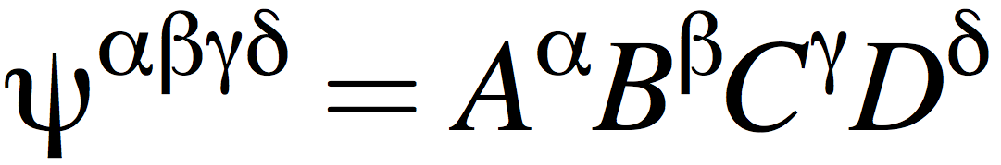

That is, the full state of the system is given by a tensor product of the states of the individual parts.

This representation is very nice because it only requires 2 ⋅ 4 pieces of information, rather than 2⁴—that is, it grows linearly with the size of the system, rather than exponentially. However, the downside of this form is that it only describes a small subset of systems; specifically, it cannot be used to model systems whose states feature correlations between the particles. For example, this representation cannot be used to model a state in which the only two nonzero configurations are all-particles-up or all-particles-down. Such systems, however, are growing increasingly important because they give rise to exotic behaviours that we would like to harness. For example, many groups are striving to build a quantum computer, which uses these correlations to perform computations that efficiently solve many problems which are intractable for classical computers.

In the last decade, there has been research in a new kind of model, called matrix product states. This model introduces bonds between the parts of the system which introduces correlations. Returning to our four particles, A, B, C, and D, introduced earlier, we would replace the vector A^{α} with A^{α}_{i}, B^{β} with B^{β}_{ij}, C^{γ} with C^{γ}_{jk}, and D^{δ} with D^{δ}_{k}, and then the full state of the system would be given by,

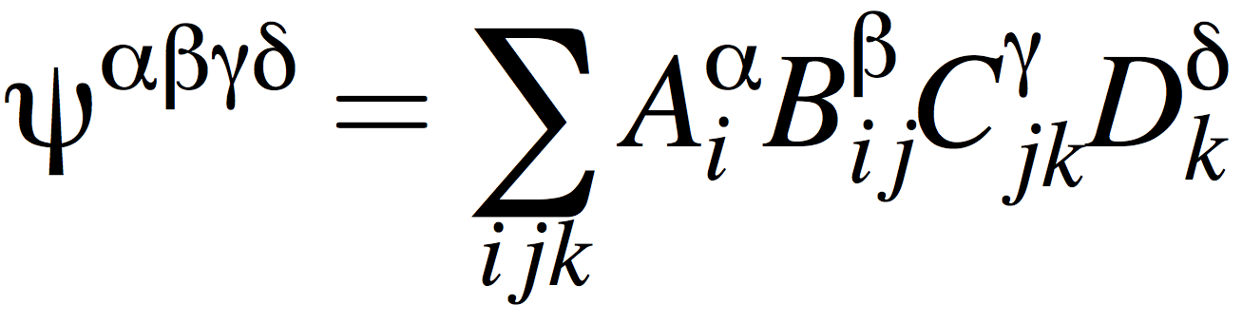

A way of visualizing such states is by using a diagram such as the following:

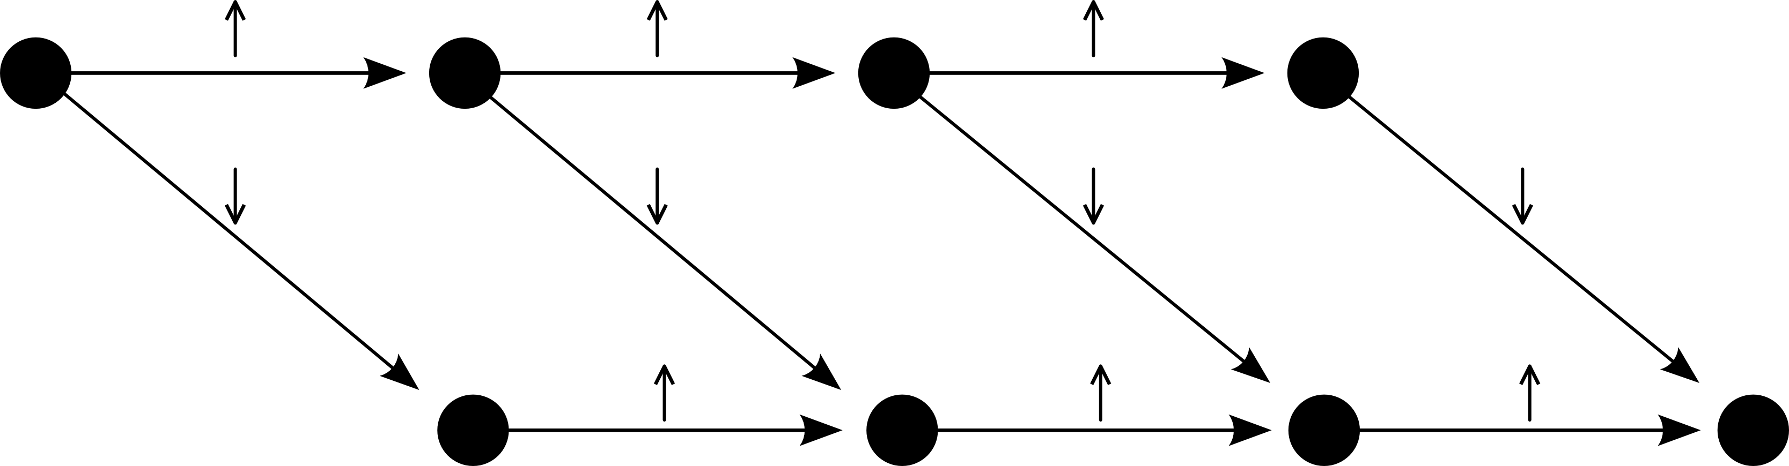

This diagram gives one possible state for our 4-particle system. Each possible configuration in this state is given by a “walk” through the diagram, so for example one such configuration is ↑↑↓↓, which corresponds to the walk given by

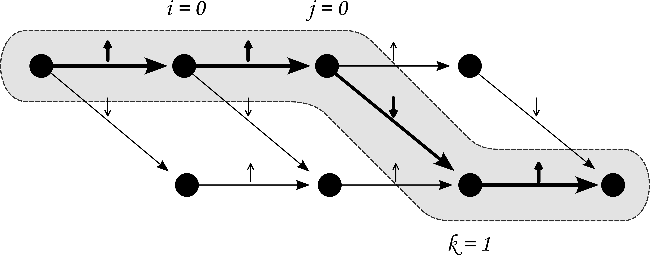

In this diagram, the connecting arrows are only labelled with a ↓ or an ↑; in general, one would have some combination of these, giving a general state for one magnetic particle.

2. Research activities:

3. Perspective of research after this program:

4. Australian advisor's remarks:

